**Child Development & Protection App.**

**Purpose**

We have a challenge in Nigeria- corrupt system. The young people believe the elderly, politicians or themselves are the ones to make the country better, completely forgetting that the children are our brightest chance of saving tomorrow. This project creates a platform that helps Nigerian children build their future. It focuses on child protection, child development, family strengthening. Children are going to be trained free in UI/UX, html, css and javascript, and when they are good to a considerable extent, they will be able to insert their self-made html file profile on this mobile and web-based application, which they can upgrade as they grow older. A link to their self made page will be posted on this website.This profile will include their story, their solution for a greater Nigeria and the role they will play in it. Their family members will be part of the whole process. Industrious and innovative children or families will be rewarded with tools including laptops.

**Audience**

The primary audience will be teenagers (or thereabout) and their parents. The secondary audience will be Civil Society Organisations, Government and Donors.

**Data sources**

-External API, localStorage, -local JSON file, -and possibly Mongo DB.

**Initial Module list**

**index.html:** Landing page + Login.

**tomorrow.html:** Children/Family Profile Page.

**child-protection.html:** Child abuse/Domestic abuse reporting page.

**Main.js & route.js**

**Pagenation-search.js:** members will be able to search for entries through name or membership number. the search field or/and also use pagenation.

**api.js:** law enforcement API

**database-connection.js:** MongoDB to save members id and password.

**Wireframe**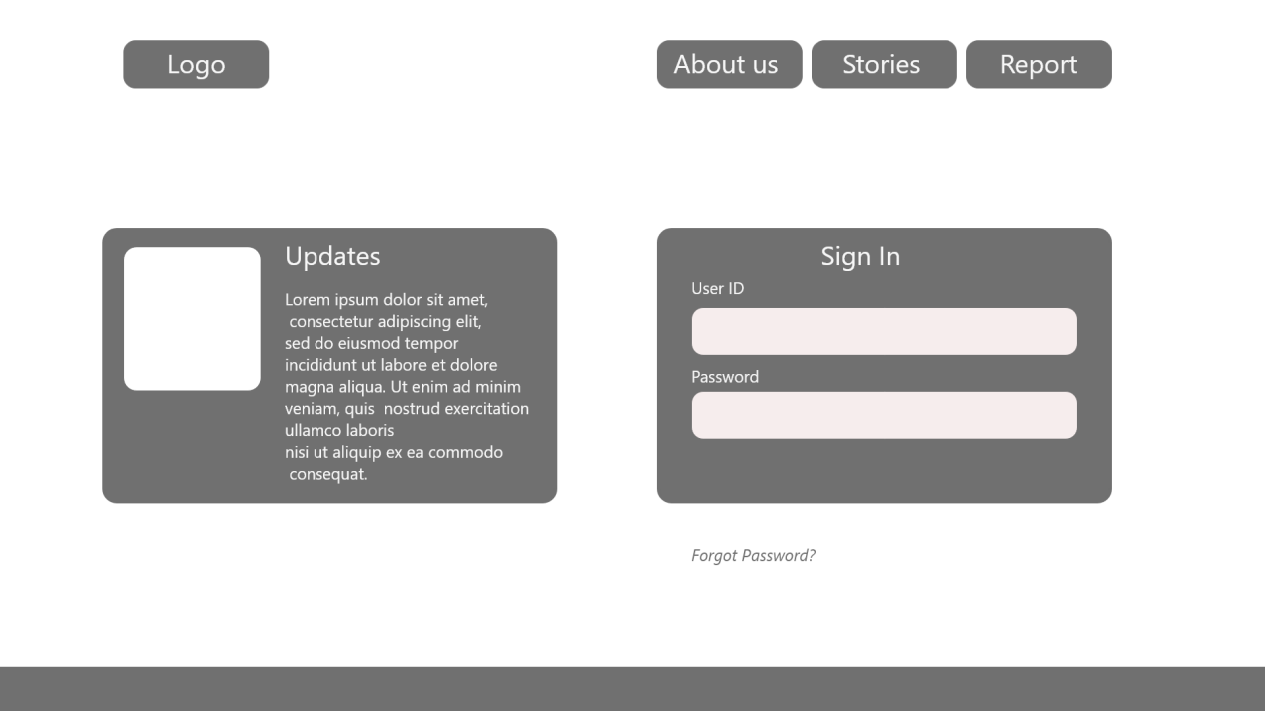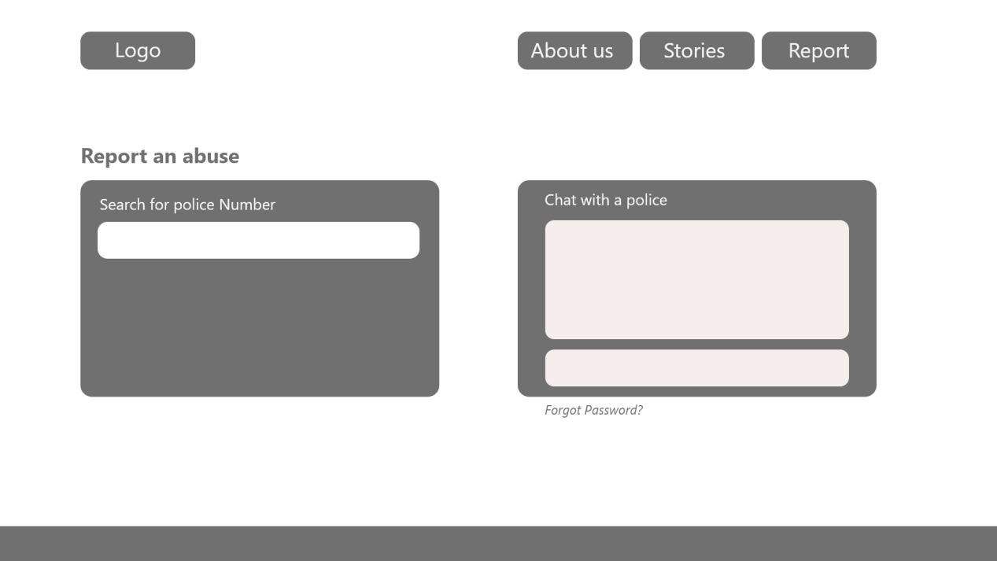

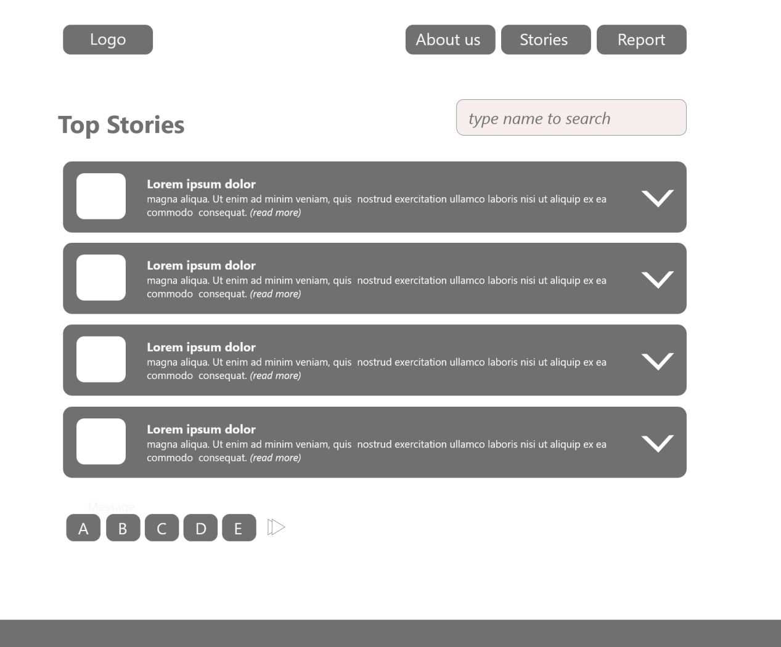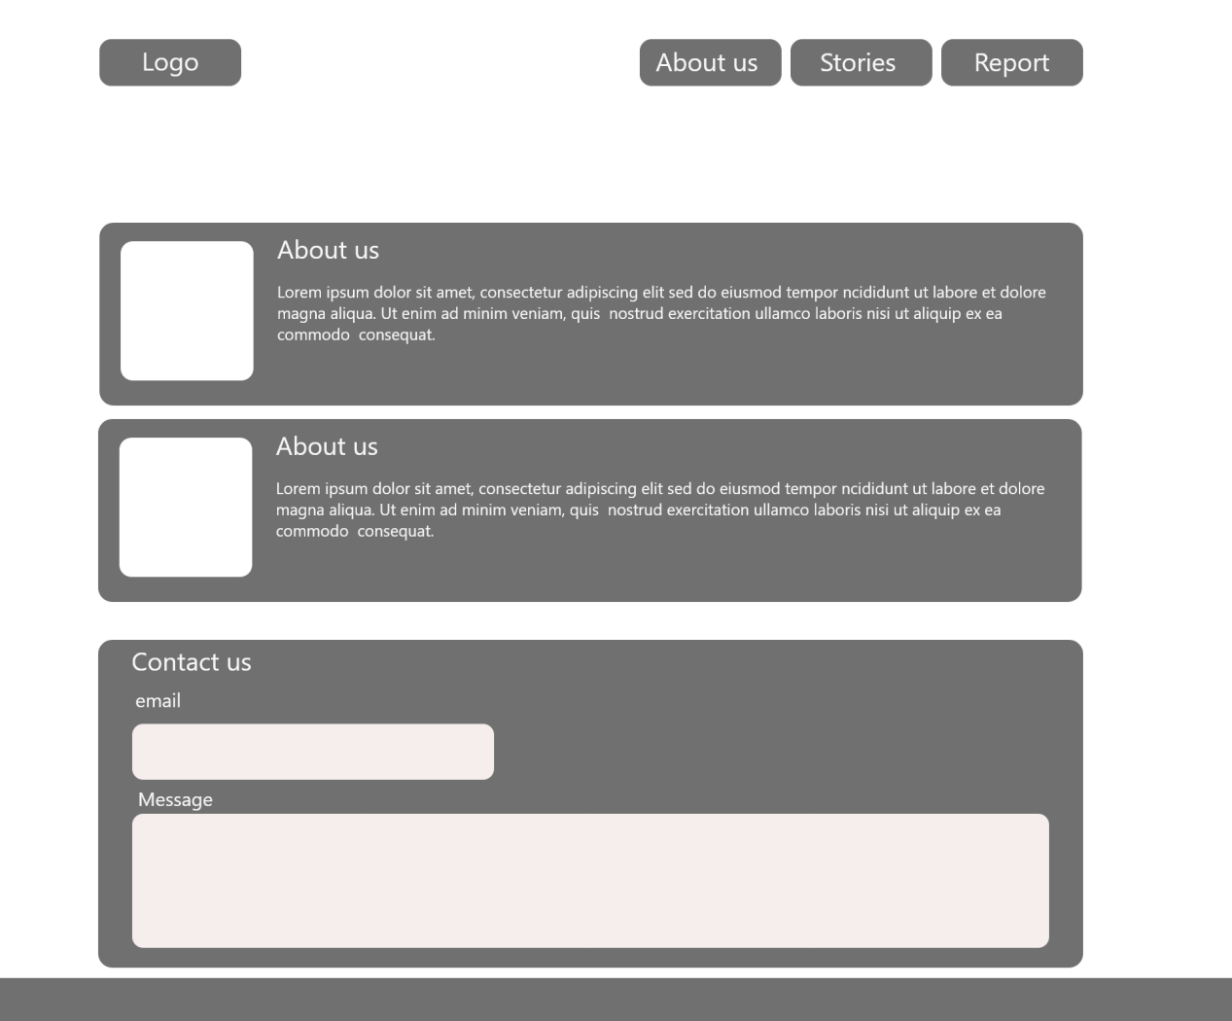

**Colors/Typography/specific Element styling**

Bright colors that depict Africa will be professionally used; Shades of red, yellow, Orange and blue, brown and black. Primary color will Orange. For the typography, I will be using helvetical, roboto and moontime for headers. The page will be friendly to children and family oriented with beautiful pictures. This proposal will be modified as better choices emerge.

**TimeLine**

|  |  |
| --- | --- |
| **Period** | **Task** |
| **Week 10** | 1. User Interface(HTML, CSS) completed 2. main.js to handle preliminary click events completed. |
| **Week 11** | pagenation-search.js completed |
| **Week 12** | api.js and routes.js completed |
| **Week 13** | database-connection.js completed |
| **Week 14** | Review and submission |
|  |  |